**Semester 1 (Unit 3) Examination, 2016**

**Question/Answer Booklet**

**MATHEMATICS APPLICATIONS**

**Section One: Calculator-assumed**

Student Name/Number: ______________________________________________

Teacher Name: ______________________________________________

**Time allowed for this section**

Reading time before commencing work: ten minutes

Working time for this section: one hundred minutes

**Materials required/recommended for this section**

**To be provided by the supervisor:** This Question/Answer Booklet

Formula Sheet (retained from Section One)

**To be provided by the candidate:**

Standard items: pens (blue/black preferred), pencils (including coloured), sharpener,

correction fluid/tape, eraser, ruler, highlighters

Special items: drawing instruments, templates, notes on 2 unfolded sheets of A4 paper, and up to three calculators approved for use in the WACE examinations

**Important note to candidates**

No other items may be taken into the examination room. It is **your** responsibility to ensure that you do not have any unauthorised notes or other items of a non-personal nature in the examination room. If you have any unauthorised material with you, hand it to the supervisor **before** reading any further.

**Structure of this paper**

|  |  |  |  |  |  |
| --- | --- | --- | --- | --- | --- |
| Section | Number of questions available | Number of questions to be answered | Working time (minutes) | Marks available | Percentage of exam |
| Section One: Calculator-free | 6 | 6 | 50 | 50 | 35 |
| Section Two: Calculator-assumed | 10 | 10 | 100 | 105 | 65 |
|  | | | | | 100 |

**Instructions to candidates**

1. The rules for the conduct of School exams are detailed in the *College assessment policy*. Sitting this examination implies that you agree to abide by these rules.
2. Write your answers in this Question/Answer Booklet.

3. You must be careful to confine your responses to the specific questions asked and to follow any instructions that are specific to a particular question.

1. Spare pages are included at the end of this booklet. They can be used for planning your responses and/or as additional space if required to continue an answer.
   * Planning: If you use the spare pages for planning, indicate this clearly at the top of the page.
   * Continuing an answer: If you need to use the space to continue an answer, indicate in the original answer space where the answer is continued, i.e. give the page number. Fill in the number of the question that you are continuing to answer at the top of the page.
2. **Show all working clearly.** Your working should be in sufficient detail to allow your answers to be checked readily and for marks to be awarded for reasoning. Incorrect answers given without supporting reasoning cannot be allocated any marks. For any question or part question worth more than two marks, valid working or justification is required to receive full marks. If you repeat any question, ensure that you cancel the answer you do not wish to have marked.
3. It is recommended that you **do not use pencil**, except in diagrams.
4. The Formula Sheet is **not** to be handed in with your Question/Answer Booklet.

**Section Two: Calculator-assumed 65% (105 Marks)**

This section has **10** questions. Answer **all** questions. Write your answers in the spaces provided. Spare pages are included at the end of this booklet. They can be used for planning your responses and/or as additional space if required to continue an answer.

* + Planning: If you use the spare pages for planning, indicate this clearly at the top of the page.
  + Continuing an answer: If you need to use the space to continue an answer, indicate in the original answer space where the answer is continued, i.e. give the page number. Fill in the number of the question that you are continuing to answer at the top of the page.

Suggested working time: **100 minutes**.

**Questions begin on the next page**

**Question 7 (14 marks)**

The amounts of total fat and total carbohydrate per 100 g for nine different packets of biscuits are recorded in the table provided.

|  |  |
| --- | --- |
| **Total fat** | **Total Carbohydrate** |
| 18 | 61 |
| 23 | 59 |
| 20 | 71 |
| 7 | 74 |
| 3 | 72 |
| 1 | 82 |
| 8 | 85 |
| 12 | 75 |
| 18 | 66 |

(a) Create a labelled scatter plot to show the relationship between the two variables using total fat as the explanatory variable. (6 marks)

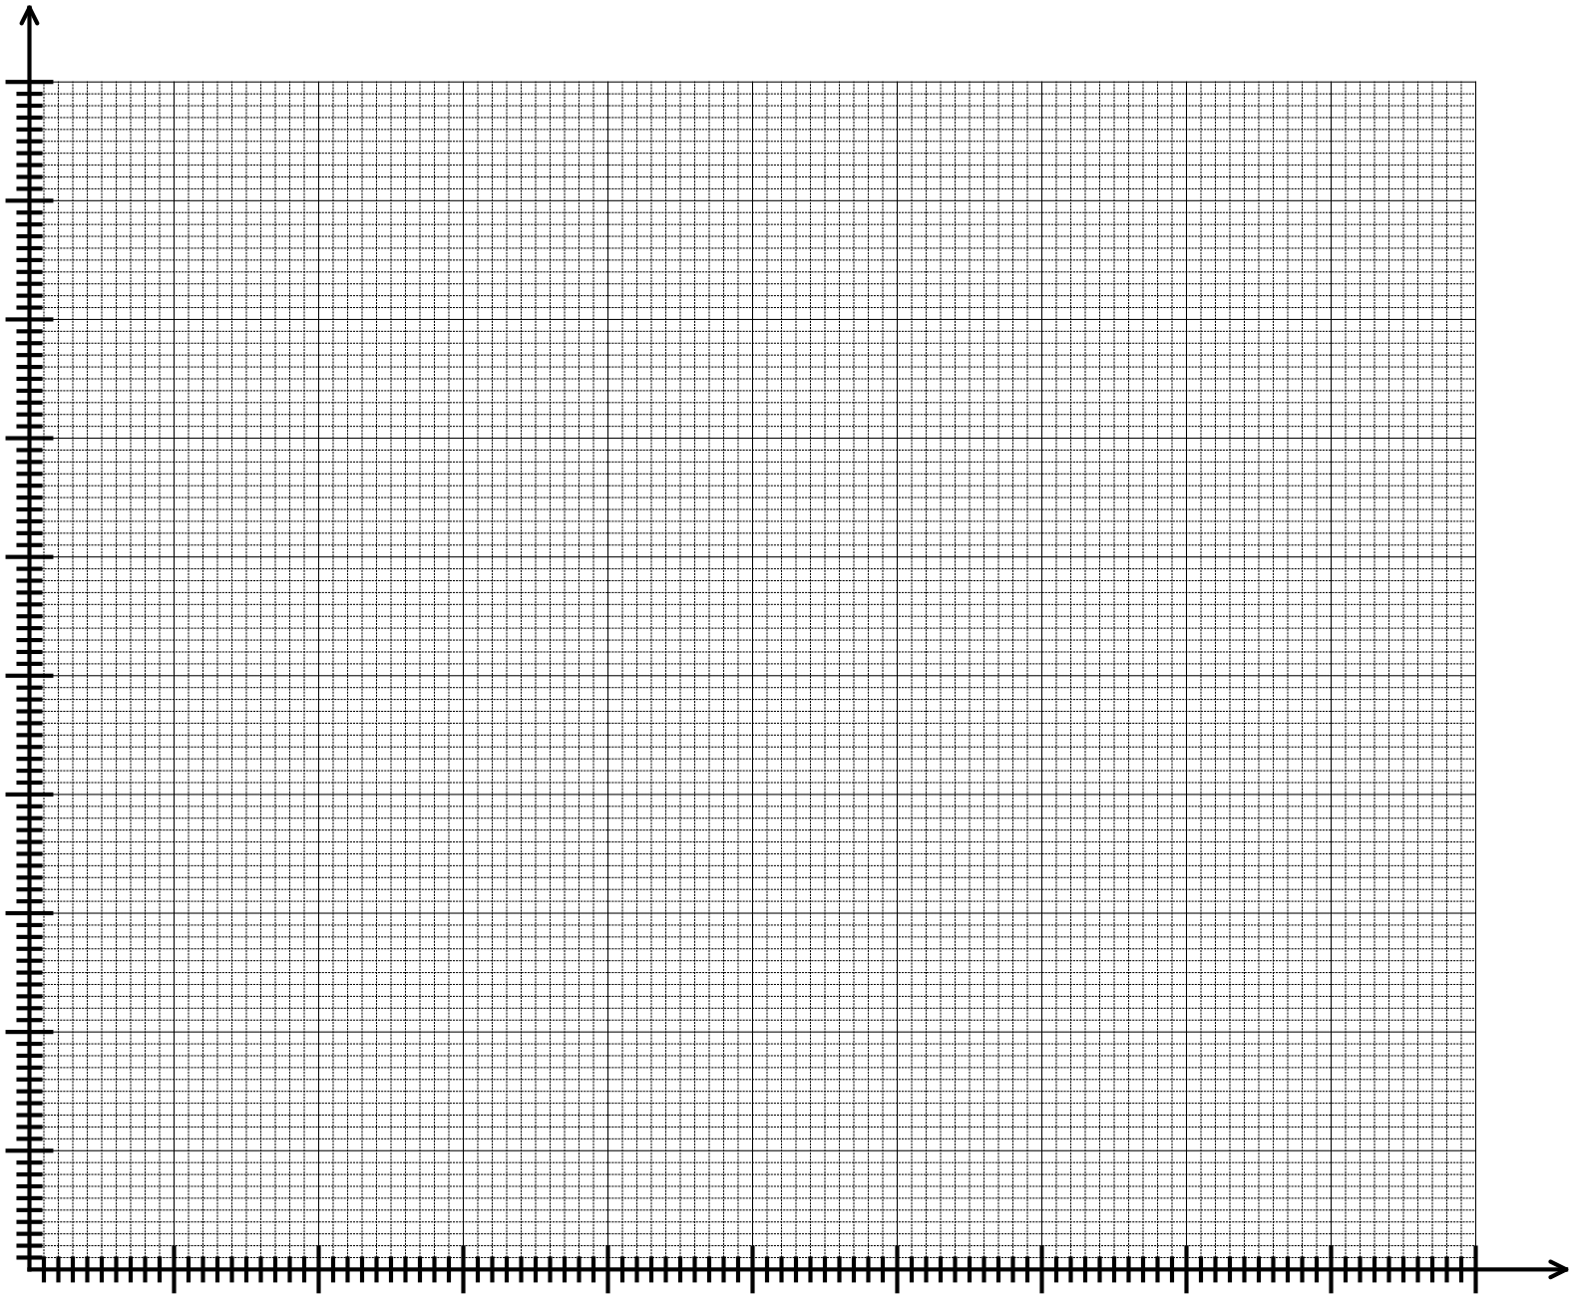

(b) Determine the

(i) equation of the least squares line that models the linear relationship between the two variables.

(2 marks)

(ii) correlation coefficient. (1 mark)

(c) Use your equation from part (b) to predict the total carbohydrate per 100 g for a packet of biscuits in which the total fat per 100 g is 30. (2 marks)

(d) Describe the reliability of your prediction in part (c) and give two reasons to justify your conclusion. (3 marks)

**Question 8 (16 marks)**

Tigers are one the world’s most endangered species. In an effort to protect the few thousand tigers remaining, reserves have been established in South Asia and the population of tigers has been increasing on these reserves.

On one reserve, the annual growth of the tiger population from 2012 to 2015 can be expressed by the recursive formula

$P_{n+1}=1.07P_{n}$ where $P_{1}$ = 427

(a) What has been the annual rate of increase in the tiger population on this reserve since 2012? (1 mark)

**Assume that the population of tigers on the reserve will continue to increase at the same rate.**

(b) Use the formula given above to complete this table, rounding to the nearest whole number. (3 marks)

|  |  |  |  |  |  |  |
| --- | --- | --- | --- | --- | --- | --- |
| Year | 2012 | 2013 | 2014 | 2015 | 2017 |  |
| Number of tigers at the end of the year | 427 |  |  |  |  | 641 |

(c) (i) Deduce the non-recursive rule for the *nth* term of the population of tigers on this reserve.

(2 marks)

(ii) Use this rule to calculate the tiger population on the reserve in 2020. (2 marks)

(d) If the data in the table were presented on a graph, would you expect the points to be in a line? Justify your decision. (2 marks)

(e) The year 2022 is the next “Year of the Tiger” on the Chinese calendar.

What is the predicted population of tigers on the reserve for 2022? (2 marks)

(f) During which year is the population of tigers expected to be greater than 1000 for the first time?

(2 marks)

(g) Describe how the prediction in part (f) will be affected if the calculation for the population changes to $P_{n+1}=1.08P_{n}$. Explain your decision. (2 marks)

**Question 9 (9 marks)**

The numbers on the edges of the network below indicate the time (in minutes) that it takes to walk between the intersections of part of the central business district of an Australian city. Jake is currently at intersection E and he wishes to walk, in the shortest possible time, to meet a friend who is waiting for him at intersection B.



(a) State the route that Jake should follow to arrive at intersection B in the shortest possible time and also state the time it would take to travel that route. Show a method by which you determined your solution.

(3 marks)

Jane also plans to walk from intersection E to intersection B. She too wants to arrive in the shortest possible time but she wants to go via the florist situated at intersection F.



(b) State the route Jane should take.

(2 marks)

(c) Jane spent 5 minutes at the florist. How much longer did the journey take Jane than it took Jake? (2 marks) (1 mark)

(d) For the network drawn above, identify a Hamiltonian path. Give a practical example of how such a path of these roads might be used. (2 marks)

**Question 10 (8 marks)**

Alex is interested in investigating the time it takes for a student in Year 12 to obtain a driver’s licence. He decides to survey the members of his football team to collect the data he needs.

(a) Suggest one way he could improve his data collection. (1 mark)

(b) Obtaining a driver’s licence consists of several activities and Alex decides to concentrate on studying the time a student spends driving a car with a supervisor before taking the Practical Driving Assessment (PDA). Determine an appropriate question for the survey. (1 mark)

Bill conducted a similar survey in his Applications class and the students approximated the number of hours they spent driving a car with a supervisor before taking the PDA. They gave their results to the nearest 5 hours. The results are provided in the table below.

|  |  |
| --- | --- |
| **Number of hours** | **Frequency** |
| 25 | 5 |
| 30 | 10 |
| 35 | 1 |
| 40 | 2 |
| 45 | 0 |
| 50 | 2 |

(c) Describe TWO ways by which Bill could have obtained more useful data. (2 marks)

(d) Provide TWO conclusions that can be made from Bill’s results. For each statement provide statistics to justify these conclusions. (4 marks)

(i)

(ii)

**Question 11 (11 marks)**

Data from the Australian Bureau of Statistics showed that the population of pigs in Australia fell by the same rate in each of the 2013-2014 and 2014-2015 financial years. Assuming the population continues to fall at the same rate each year and the population at the end of June 2015 is approximately 242 thousand, the *n*th term of the sequence,

*P* = 242 (0.985) *n*-1

gives the expected population of pigs (in thousands), n years after 30 June, 2015.

The graph shows the expected change in population over time (years).

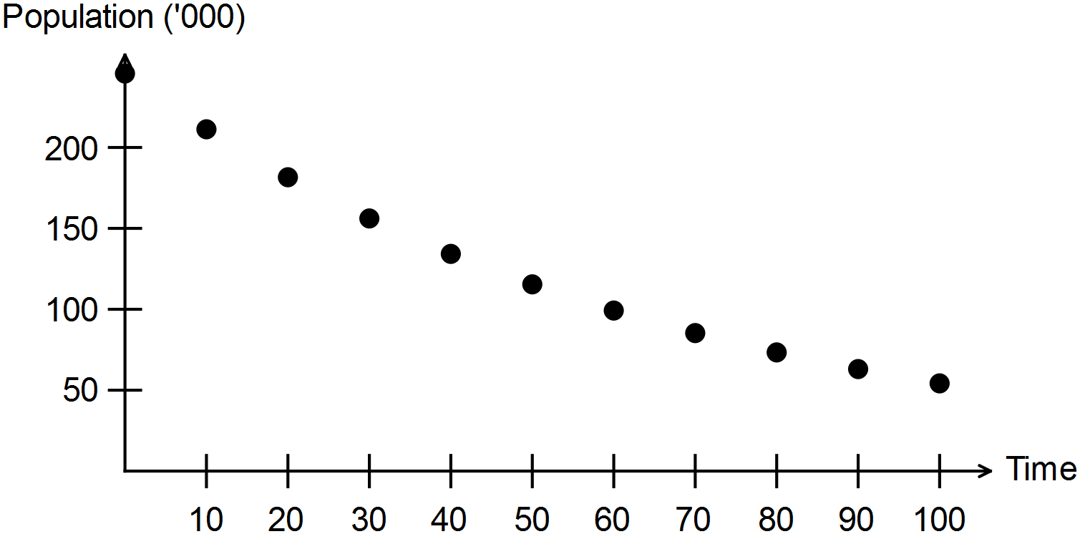

(a) Determine the rate at which the population is falling each year. (1 mark)

(b) Describe the type and nature of the change in the predicted population. (2 marks)

(c) State the value of the first term of the sequence. (1 mark)

(d) Determine the expected size of the pig population in Australia at the end of June 2021.

(1 mark)

(e) If populations are recorded every 12 months, when will the population of pigs first be recorded as below 200 000? (2 marks)

(f) To halt the decline in the pig population, it has been suggested that 5000 pigs could be imported each year. Complete the table provided to show the pig populations with and without this option and complete the rules to determine the recurrence relation for each option.

(4 marks)

|  |  |  |
| --- | --- | --- |
| **Date** | **No pigs imported** | **5000 pigs imported each year after 2015** |
| **30 Jun 2015** | 242 000 | 242 000 |
| **30 Jun 2016** |  |  |
| **30 Jun 2017** |  |  |
|  |  |  |
| **Linear recurrence relation** | *P*0 = 242 000  ............................................. | *P*0 = 242 000  .................................................... |

**Question 12 (10 marks)**

In the CensusAtSchool survey in 2013, respondents were asked the following question:

“How do you usually spend your time on the internet?” The tables below show the percentages of students who selected each of the categories *never, rarely, sometimes* and *often* for six uses of the internet.

|  |  |  |  |  |  |  |
| --- | --- | --- | --- | --- | --- | --- |
| **FEMALES** |  | | | | | |
|  | **Shopping** | **Email** | **Games** | **Research** | **Browsing** | **Social networking** |
| **never** | 53.6 | 20.5 | 20.5 | 4 | 7.5 | 18.1 |
| **rarely** | 27.9 | 38.3 | 34.6 | 21.1 | 28.8 | 10.4 |
| **sometimes** | 13.6 | 27.5 | 26.2 | 47.9 | 43.3 | 19.3 |
| **often** | 4.8 | 13.6 | 18.7 | A | 20.4 | 52.3 |

|  |  |  |  |  |  |  |
| --- | --- | --- | --- | --- | --- | --- |
| **MALES** |  |  |  |  |  |  |
|  | **Shopping** | **Email** | **Games** | **Research** | **Browsing** | **Social networking** |
| **never** | 46.9 | 31.6 | 7 | 10.9 | 10 | 23.9 |
| **rarely** | 30.9 | 37.6 | 17.6 | 28.8 | 26.7 | 15.4 |
| **sometimes** | 15.6 | 21.3 | 28.2 | 42.8 | 41.6 | 23.1 |
| **often** | 6.7 | 9.5 | 47.3 | 17.4 | 21.7 | 37.6 |

(a) Calculate the value represented by A. (1 mark)

(b) Explain why the sum of the percentages of females using the internet to shop in each of the categories is not equal to 100%. (1 mark)

(c) Use the data to identify the least popular of these internet uses among the female respondents to the survey. (1 mark)

(d) Use the data to identify the most popular of these internet uses among the male respondents to the survey. (1 mark)

(e) Describe TWO ways in which the use of the internet for email by male and female respondents are different and provide data from the table to justify your conclusion.

(2 marks)

(f) The percentages of female and male respondents using the internet for browsing were 92.5% and 90% respectively. This does not indicate that the number of times the internet was used for browsing by females responding to the survey was greater than the number of times for male respondents. Give two reasons to justify this conclusion.

(2 marks)

(g) Consider the following statement:

*Female respondents spent more time using the internet for social networking than male respondents did.*

State whether the conclusion is definitely TRUE, definitely FALSE or NOT SUPPORTED and justify your decision. (2 marks)

**Question 13 (12 marks)**

The points on the graph below represent the cost of an economy one-way flight ($) and the flying distance (km) to various holiday destinations. Use the data for the questions to follow.

(a) What was the cost of the most expensive flight? (1 mark)

(b) Identify the response variable. (1 mark)

(c) Circle the data point representing the city which is a flying distance of 6000 km and for which a ticket costs $472. (1 mark)

One outlier was removed and then the following statistics were calculated

The coefficient of determination: *r*2 = 0.9538

Equation for the least squares line: Cost ($) = 0.103 x distance – 7.166

(d) Determine the percentage of variation in cost that can be explained by the change in distance. (1 mark)

(e) Calculate the correlation coefficient. (1 mark)

(f) Which of the values, 0.88 or 0.98 is more likely to have been the coefficient of determination before the outlier was removed? Explain your decision. (2 marks)

For a city located at a distance of approximately 10 000 km,

(g) use the equation provided to predict the cost of a one-way economy flight. (2 marks)

(h) plot the data point on the graph above. (1 mark)

(i) describe the reliability of your prediction to part (g) and justify your conclusion.

(2 marks)

**Question 14 (13 marks)**

The adjacency matrix shows the results of five students competing in a chess competition. Each student plays a game against each of the other students. A win is represented by 1 and a loss as 0. Each row represents the wins and losses for the player whose initial occurs at the beginning of the row. Each student is competing against the player whose initial is at the top of the column. The adjacency matrix (*M*) shows that Tom (T) beat Kate (K) and Andrew (A) but lost to Jane (J) and Liz (L).



*T*

*M = K*

*J*

*A*

*L*

(a) Explain the pattern of values on the leading diagonal of the adjacency matrix. (1 mark)

(b) Describe what the sum of each row represents. (2 marks)

(c) *In the adjacency matrix, if the element in row m and column n is 0 then the element in row n and column m is 1.* Explain the meaning of this statement. (2 marks)

(d) Use the vertices provided to construct the digraph represented by the adjacency matrix *M*. (3 marks)

*J*

*K*

*T*

*A*

*L*

The square of matrix *M* is given below.



*T*

*M 2 = K*

*J*

*A*

*L*

(e) Tom beat two people who also beat Jane.

(i) Who were they? (1 mark)

(ii) Where is this represented in *M 2* ? (1 mark)

(f) What number occurs in column 5 of row 3? Describe what this number represents.

(2 marks)

(g) How many students beat only one other person who had also beaten Kate? (1 mark)

**Question 15 (6 marks)**

For each of the sequences given below, describe the pattern by selecting the appropriate description in each column and writing the description in the table provided.

|  |  |  |  |
| --- | --- | --- | --- |
| **Sequence** | **Arithmetic or geometric** | **Exponential or linear** | **Growth or decay** |
| **A** |  |  |  |
| **B** |  |  |  |
| **C** |  |  |  |
| **D** |  |  |  |
| **E** |  |  |  |
| **F** |  |  |  |

|  |  |
| --- | --- |
| **A** | **B**  Each year the number of cards that Kay sends to her friends is 0.9 times the number she sent the previous year. Consider the sequence formed by listing the number of cards that Kay sends each year. |
| **C**   |  |  |  |  |  |  | | --- | --- | --- | --- | --- | --- | | *n* | 1 | 2 | 3 | 4 | 5 | | *Tn* | 128 | 96 | 72 | 54 | 40.5 | | **D**   |  |  |  |  |  |  | | --- | --- | --- | --- | --- | --- | | *n* | 1 | 2 | 3 | 4 | 5 | | *Tn* | -100 | -90 | -80 | -70 | -60 | |
| **E**  For the first five weeks of his new job, Joel works an extra 2.5 hours each week. Consider the sequence formed by listing the number of hours that Joel works each week. | **F**  The number of library books needing to be replaced each year is deemed to be declining at a rate of 10%. Consider the sequence formed by listing the number of books needing to be replaced each year. |

**Question 16 (6 marks)**

On the graph below the horizontal axis represents the percentage of students “doing Vet” and the vertical axis represents the percentage of students receiving “an ATAR”. Each point represents a different school. The data was sourced from tables published in the West Australian newspaper in January 2016.

(a) Describe what tends to happen to the percentage of students receiving an ATAR as the percentage of students “doing Vet” increases. (1 mark)

(b) What do the following features of the pattern of the dots indicate about the nature of the relationship between the two variables? (3 marks)

(i) The dots are heading in a downwards direction.

(ii) The dots are nearly in a straight line.

(iii) The dots are close together.

(c) Consider and explain possible causes of the relationship between the two variables.

(2 marks)

**End of Questions**

Additional working space

Question number: __________________

**Acknowledgements**

© MAWA, 2016

This examination is Copyright but may be freely used within the school that purchases this licence.

* The items that are contained in this examination are to be used solely in the school for which they are purchased.
* They are not to be shared in any manner with a school which has not purchased their own licence.
* The items and the solutions/marking keys are to be kept confidentially and not copied or made available to anyone who is not a teacher at the school. Teachers may give feedback to students in the form of showing them how the work is marked but students are not to retain a copy of the paper or marking guide until the agreed release date stipulated in the purchasing agreement/licence.

*Published by The Mathematical Association of WA*

*12 Cobbler Place, MIRRABOOKA 6…*